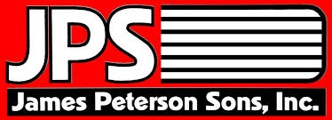  James Peterson Sons, Inc. |  | Phone: (715) 748-3035  Fax: (715) 748-4530
Heavy &
Highway Construction
PO Box 120 • Medford, WI 54451 • www.jamespetersonsonsinc.com • jpsinc@jpsbp.com

March 20, 2023

RE: DBE Participation
WIDOT Letting of April 11th, 2023

Subcontractor,

We are considering accepting and or providing quotes for a number of projects in the April 11, 2023 WIDOT Letting.

Proposal #’s:
2,3,4,8 and 9
To be compliant with the Disadvantaged Business Enterprise Program (DBE) that has been established by the WI Department of Transportation (WisDOT) and also with regulations established by the U. S. Department of Transportation (USDOT), 49 CFR Part 26. WisDOT receives funds from USDOT for many of projects we are all bidding on and as a condition of receiving those funds WisDOT has a requirement that a percentage of the projects that contain USDOT funding be contracted to DBE firms. DBE participation could be obtained through a traditional subcontractor, trucking, a vendor supplying materials or any combination of these.

JPS encourages you to do your due diligence to both solicit and utilize DBE firms (subcontractor, trucking, supplier etc.) when you are preparing your quotes for the upcoming WisDOT letting. Your quotes may be evaluated on a combination of both the lowest cost and the amount of DBE participation that you may have been able to include in your total when compared to other quotes for the same work.

Please submit quotes to bidding@jpsbp.com

If you have any questions or would like to discuss any of this please contact me.

Sincerely,

Jeffery J Peterson

Jeffery J Peterson
President
James Peterson Sons, Inc

